SmartPark by $oftware ¢orp - Smart Parking Platform Project

v 6.4

Bookmarks:
SRS
WBS
GanttChart
JiraScrumBoard
RiskCategories
RiskRegister
CommunicationPlan
RolesResourcesPlan
CostPlan
Cashflow
RACImatrix
PowerInterestGrid
TeamCharter
ProjectCharter

Existing Software Landscape:
Most used parking platforms in Houston: ParkHouston by ParkMobile, SpotHero, ParkWhiz
Shared core features:
- Search for participating parking garages on map via GPS
- GPS integration within app with directional navigation to garage from current location
- Reserve spot ahead of time or on the spot in parking garages or street lots
- Extended parking time up to maximum limit via app
- Electronic receipt system via QR code or license plate recognition
- Payment in app via credit/debit card, Apple/Google Pay, PayPal
- Register several license plates/save several cars to single account
- Receive notifications for parking expiration
- Track purchase history
Unique Features:
- ParkHouston by ParkMobile:
  - Mobile and web parking service for city-managed street and garage parking in Houston
  - Most common for on-the-spot street parking in municipal areas
  - Feature: Find car with directions back to parking spot

- SpotHero:
  - Mobile and web parking service for private street and garage parking or event parking across the U.S.
  - Large number of participating garages in many cities
  - Most common for garage parking with reservations

- ParkWhiz:
  - Mobile and web parking service for private street and garage parking or event parking across the U.S.
  - Most common for reserving event parking, such as concerts, sports games, venues
  - Offers discounts/coupons
What SmartPark Houston will offer:
The SmartPark Houston by $oftware ¢orp application will stand out in its partnership with all garage operators in the Houston downtown area, so that drivers can have access to search all parking garages in a single app; no need to download several apps to find the best garage option. Also, SmartPark will have various modes of access, such as app, site, QR code, and text-to-pay to better serve the preferences of all drivers. SmartPark will establish a loyalty/benefits program for frequent travelers to save up rewards, earn coupons and discounts with each reservation.

Software Requirements Specification (SRS)
Project: SmartPark Houston – a Smart Parking Platform by $oftware ¢orp
Version: 6.4
Date: September 10, 2026
- Introduction:
$oftware ¢orp has recognized the demand for better parking management in the Houston area due to a large population of commuting residents and an increase in tourism. As a leader in software development, we are determined to present a modern solution to optimize garage parking services for both users and operators.

- Purpose
The goal of SmartPark Houston is to optimize parking management for both drivers and garage operators through software that provides information for parking availability, reservation, navigation, and payment all in one platform. This document defines the requirements for SmartPark.

- Scope
- Create a website and mobile application that integrates with partnered private garages in Houston
- Allow vehicle owners/drivers to reserve a parking space in real-time or in advance, use navigation, and complete payments within the app
- Allow garage operators to monitor occupancy and manage pricing
- Semester timeline - to be completed within 4 months
Out of scope:
- Extended timeline
- Integration with parking garages outside of Houston downtown area
- Integration with “buy now, pay later” platforms, such as Klarna, Afterpay

- Overall Description:
- Users: Drivers/vehicle owners, garage operators (admin)
- System Environment: Website and mobile application
- Constraints:
  - Must require vehicle registration via license plate, must be compatible with partnered parking garages, must show live/real-time information, must be compatible with GPS, must integrate with payment platforms.
  - Fixed timeline – semester (4 months)
  - Unlimited budget
  - Dependence on third-party services
  - Compliance with security, privacy regulations, city laws

- Assumptions: Developers/development team is available to work on project, studio has technology equipment needed to develop software, parking garages have capabilities to utilize mobile parking services

- Use Case Examples:

- Title: Application Installation
Actor: User
Goal: Install SmartPark app on iPhone
Precondition: User owns iPhone device, has AppStore
Steps:
- User opens AppStore application
- User searches for “SmartPark”
- User selects “Get” to install app
- User selects “Open” to open app on home screen

- Title: Application Installation
Actor: User
Goal: Install SmartPark app on Android
Precondition: User own Android device, has Google Play Store
Steps:
- User opens Google Play Store application
- User searches for “SmartPark”
- User selects “Install” to install app
- User selects “Open” to open app on home screen

- Title: Registration for drivers
Actor: User (vehicle owner/driver)
Goal: Create user account
Steps:
- User selects “Driver Sign Up”
- User inputs username/email, password
- User adds vehicle license plate number and car details
- User saves login information

- Title: Registration for operators
Actor: User (parking garage operator)
Goal: Create admin account
Steps:
- User selects “Operator Sign Up”
- User inputs username/email, password
- User adds parking garage location, documentation
- User saves login information

- Title: Adding Payment Preference
Actor: User (vehicle owner/driver)
Goal: Save payment information for Credit/Debit card
Precondition: User is logged into app
Steps:
- User selects “Select Payment Option”
- User selects “Credit/Debit card”
- User selects “Visa”, “Mastercard”, or “American Express”
- User inputs card number, expiration, security code
- User selects “Save”
Postcondition: User can pay automatically upon checkout with saved card
- Title: Paying with Digital Wallet on iPhone
Actor: User (vehicle owner/driver)
Goal: Pay for parking using digital wallet
Precondition: User is logged into app and is ready to pay
Steps:
- User selects “Apple Pay”
- User reviews parking reservation details
- User double clicks side button and enters face ID to authenticate payment
- Screen shows checkmark to confirm payment was successful
- User receives message of the Apple Pay payment
Postconditions: User receives text or email receipt from SmartPark with reservation details and payment confirmation

- Title: Paying with Digital Wallet on Android
Actor: User (vehicle owner/driver)
Goal: Pay for parking using digital wallet
Precondition: User is logged into app and is ready to pay. User has set up Google pay by connecting it with credit/debit card
Steps:
- User selects “Google Pay”
- User reviews credit/debit card information
- User reviews parking reservation details
- User authenticates payment with face ID or passcode
- Screen shows checkmark to confirm payment was successful
Postconditions: User receives text or email receipt from SmartPark with reservation details and payment confirmation
- Title: Paying with Text-to-Pay
Actor: User (vehicle owner/driver)
Goal: Pay for parking via text-to-pay feature for on-the-spot parking
Preconditions: User has located a Text-to-Pay sign with text code information. User does not have an account with SmartPark.
Steps:
- User texts the number written on the Text-to-Pay sign from a mobile device
- User receives a link
- User is directed to the SmartPark website after clicking on the link
- User confirms parking garage name and location
- User is prompted to enter name, contact information, vehicle details/license plate number.
- User saves details, selects “Continue”
- User is directed to the payment page
- User chooses desired payment option
- User confirms card details
- User authenticates payment
- User receives confirmation of successful payment
Postcondition: User receives text or email receipt from SmartPark with reservation details and payment confirmation

- Title: Search for available parking spots
Actor: User (vehicle owner/driver)
Goal: See live availability of parking spots in garage
Precondition: User is logged into app
Steps:
- User selects map feature showing Houston downtown area
- User sees all partnered garages indicated by dots
- User selects one available parking garage indicated by a green dot
- User sees the name of the selected garage and the number of available spaces

- Title: Parking reservation in advance
Actor: User (vehicle owner/driver)
Goal: Reserve parking space in garage ahead of time
Precondition: User is logged into app and has selected desired garage
Steps:
- User confirms selected garage has space availability
- User selects “Continue”
- User enters date and time for reservation
- User selects “Continue”
- User reviews confirmation page with garage information, vehicle details, date of reservation, duration of reservation, contact information, cost
- User selects “Checkout”
Postcondition: User pays for parking space and receives receipt for reservation

- Title: Extending parking reservation time
Actor: User (vehicle owner/driver)
Goal: Extend time for parking space
Precondition: User is logged into app, has paid for space, and is actively parked
Steps:
- User selects “Extend reservation” control
- User is prompted to enter time in minutes and hours to be added to the current reservation window
- User sees the cost of the additional time
- User selects “Confirm”
- User is prompted to enter payment information or select the same method as was used for the original reservation
- User confirms payment with Face ID or passcode authentication
- User receives confirmation page showing successful payment
- User receives text or email receipt showing new expiration time for parking space

- Title: Navigational Services
Actor: User (vehicle owner/driver)
Goal: Direct user to garage location in app
Precondition: User is logged into app
Steps:
- User selects “Map”
- User searches location and selects desired parking garage
- User selects “Directions”
- User is prompted to enter their location/address as the “From”
- User selects “Go”
- User receives visual and verbal navigational instructions within the SmartPark app
- User selects “Arrived” once arrived and parked at destination

- Title: Car Location Services
Actor: User (vehicle owner/driver)
Goal: Locate car in garage structure
Precondition: User is logged into app and is returning to garage at the end of their reservation. User has location services on for SmartPark app
Steps:
- User selects “Active Parking”
- User confirms their current parking space reservation
- User selects “Locate Car”
- User is redirected to the map feature
- User receives directional instructions indicated by an arrow along mapped streets
- User follows arrow to parking garage structure and enters
- User is redirected to the garage layout map
- User receives instructions with floor number, zone letter, and space number of their parked car
- User selects “Car Found” to end directions

- Title: Payment tracking
Actor: Admin (Parking garage operator)
Goal: Show earning details
Precondition: User is logged into app
Steps:
- User selects “Earnings Report” on dashboard
- User enters desired date
- User receives a page showing the total earnings for the selected day
- User selects “Save Report”

- Title: Occupancy reporting
Actor: Admin (Parking garage operator)
Goal: Report number of reserved parking spaces in garage
Precondition: User is logged into app
Steps:
- User selects “Occupancy Report” on dashboard
- User enters desired date
- User receives a page showing the total number of garage reservations/occupants on a selected day
- User selects “Save Report”

- Title: Garage hours
Actor: Admin (Parking garage operator)
Goal: Edit garage operating hours and rates
Precondition: User is logged into app
Steps:
- User selects specific garage from dashboard
- User selects “Edit”
- User selects “Garage hours”
- User inputs opening and closing time
- User Selects “save”
- User

- Title: Garage rates
Actor: Admin (Parking garage operator)
Goal: Edit garage parking rates
Precondition: User is logged into app
Steps:
- User selects specific garage from dashboard
- User selects “Edit”
- User selects “Parking rates”
- User selects specific days and hours
- User inputs dollar amount per parking spot
- User selects “Save”
Post condition: User can repeat steps to display different rates for different days, times, or events

- Title: Garage security incidents
Actor: Admin (Parking garage operator)
Goal: Show safety and security incidents reported by users
Precondition: User is logged into app
Steps:
- Operator (user) selects specific garage from dashboard
- User is taken to garage-specific analytics page
- User selects date
- User selects “Security Report”
- Display shows reported incidents by user regarding parking violations, vehicle damages, security concerns, etc

- Title: User logout
Actor: User (vehicle owner/driver)
Goal: Log out of account in app
Precondition: User is logged into app
Steps:
- User selects “Profile” icon
- User selects “ Account settings”
- User scrolls down the settings menu
- User selects “Logout” button
- User selects “Confirm log out”
Post condition: User is redirected to app start page

- Title: User support services
Actor: User (vehicle owner/driver)
Goal: Request technical support for in-app services
Precondition: User is logged into app
Steps:
- User selects “ Support” icon on homepage
- User selects “Live Chat” or “Call” button
- User is prompted to enter issue type
- User connects with support service personnel

- Title: User feedback
Actor: User (vehicle owner/driver)
Goal: Submit feedback about app experience
Precondition: User is logged into app
Steps:
- User selects “Support” icon on homepage
- User selects “Leave Feedback” button
- User types out feedback in text box
- User rates service quality on scale
- User selects “Send”

- Title: Web Application Access
Actor: User
Goal: Access parking platform via website
Precondition: User is on a digital device
Steps:
- User types SmartPark Houston or enter URL in search engine
- User opens SmartPark Houston website from results
- User follow prompts to create an account or sign in

- Title: Guest user sign-in
Actor: User (vehicle owner/driver)
Goal: Access parking platform as a one-time user
Precondition: User has opened SmartPark on website or app
Steps:
- User selects “Guest” income on homepage
- User enters name in box
- User enters vehicle license plate in box
- User selects “Continue”
Post condition: User has access to parking app services to make a one-time reservation

- Title: User two-factor authentication
Actor: User
Goal: Security verification of user identity
Precondition: User is on a digital device and has Microsoft Authenticator installed
Steps:
- User selects “create account” to enter username, password, vehicle info
- User selects “Two-factor authentication set up”
- User is redirected to the Microsoft Authenticator app
- User adds SmartPark Houston and saves to account
- User enters phone number and/or email for retrieval methods
- User selects “Save”
Post condition: User returns to SmartPark platform to continue

- Title: QR code access
Actor: User (vehicle owner/driver)
Goal: Show earning details
Precondition: User has a mobile device
Steps:
- User directs phone camera to QR code label located in garage
- User selects link pop-up
- User is redirected to Smart Park application
- User is prompted to enter sign-in details

- Title: Adding reservation to cart
Actor: User (vehicle owner/driver)
Goal: Add reservation to cart for later purchase
Precondition: User is logged into app and has selected desired garage
Steps:
- User confirms selected garage has space availability
- User selects “Continue”
- User enters date and time for reservation
- User selects “Continue”
- User reviews confirmation page with garage information, vehicle details, date of reservation, duration of reservation, contact information, cost
- User selects “Save for later” button
Post-condition: Reservation with selected date, time, cost is held under user’s account for 24 hours, before it gets removed

- Title: User reservation history
Actor: User (vehicle owner/driver)
Goal: Access history of parking space reservations in account
Precondition: User is logged into app
Steps:
- User selects “Account” icon on homepage
- User selects “Session Management” icon
- User selects “Past sessions” button
- User scrolls list of past reservations, starting with most recent
- User selects search bar to enter specific reservation date
- User finds one reservation and selects “View” for receipt with more details

- Title: Save favorite garages
Actor: User (vehicle owner/driver)
Goal: Save garage to favorites for later reference
Precondition: User is logged into app
Steps:
- User searches for desired garage
- User selects “View” to open specific garage profile
- User taps the heart icon on garage profile page
- Garage is saved to user account under “Favorites” in profile
Post condition: User navigates to account profile, selects “Favorites” icon to quickly access desired garage

- Title: User notifications for expiration
Actor: User (vehicle owner/driver)
Goal: Receive notification for expiration of parking reservation
Precondition: User has enabled notification for SmartPark app
Steps:
- User receives app notification 30 minutes before parking reservation expiration
- User receives app notification 15 minutes before parking reservation expiration
- User clicks on notification bubble
- User is redirected to SmartPark app
- User views page with reservation details with countdown to reservation end

- Title: User notifications for extension
Actor: User (vehicle owner/driver)
Goal: Receive notification to extend parking reservation
Precondition: User has enabled notification for SmartPark app and is logged into app
Steps:
- User selects “Account”
- User selects “Session management”
- User selects “Active sessions”
- User opens active session
- User selects “View details” icon
- User views page with reservation details with countdown to reservation end
- User selects “Extend time” icon
- User enters hours and minutes for extension
- User selects “Confirm”
- User receives updated reservation receipt with new details and new charge

Work Breakdown Structure (WBS)
- Smart Parking Platform (Web and Mobile Application)

  - Research
    - Existing Software Landscape

  - Requirements
    - SRS
      - Use Cases

  - Authentication
    - Registration
      - Guest account
        - Name
        - Vehicle/license plate
      - User account
        - Username and password
        - Vehicle/license plate
        - Security verification (2FA)
    - Login
      - Autocomplete
    - QR code access

  - User Setup
    - Dashboard
      - Map integration
      - Notifications
    - Profile
      - Account settings
      - Log out
      - Receipts
      - Notification preferences
      - Save favorites
      - User support
        - Issue reports
        - Submit feedback
    - Session Management
      - New reservation
      - Past reservations
      - Saved reservations

  - Operator Setup
    - Dashboard
      - Map integration
      - Notifications
    - Profile
      - Account settings
      - Garage locations
        - Pricing
        - Hours
      - Log out
      - Notification preferences
      - User support
        - Issue reports
        - Submit feedback
    - Analytics/Reports
        - Financial reports
        - Occupancy reports
        - Safety reports

  - Garage Monitoring
    - Map search
      - GPS integration
      - Search filters
    - Select garage
    - Spot availability
    - Booking reservation

  - Payment
    - Text-to-pay
    - Payment gateway
      - PayPal integration
      - Apple Pay integration
      - Google Pay integration
      - Credit/Debit integration
        - Visa
        - Mastercard
        - American Express

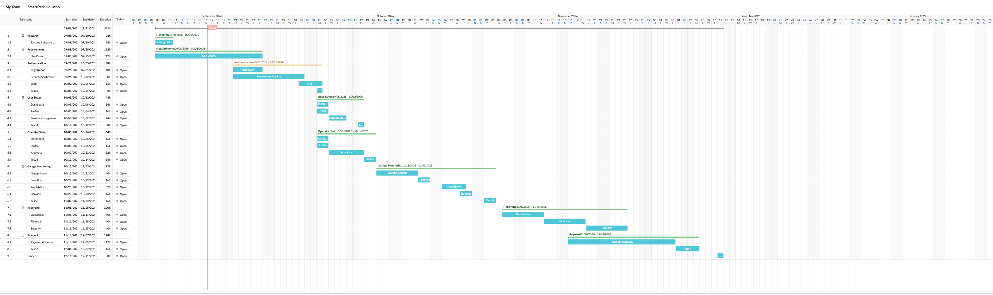
Gantt Chart

Story points:

Timeline:

Chart:

Story points (SP) with timeline estimation:

- Existing Software Landscape – 1 SP (~48-72 hrs)
- Use Cases – 1SP (~1-2 wks)
- Login – 2 SP (~24-48 hrs)
- Guest account – 2SP (24-48 hrs)
- Autocomplete – 1 SP (~24 hrs)
- QR code access – 1 SP (~24hrs)
- Username and password – 2 SP (~24-48 hrs)
- Vehicle/license plate – 3 SP (~24-48 hrs)
- Security verification – 5 SP (~72-96 hrs)
- User/Operator Dashboard – 5 SP (~72-96 hrs)
- Map integration – 8 SP (1-2 wks)
- Profile management – 5 SP (~24-48 hrs)
- New reservation management – 5 SP (~24-48 hrs)
- Past reservations management – 5 SP (~24-48 hrs)
- Notifications – 5 SP (~48-72 hrs)
- Logout – 2 SP (~24-48 hrs)
- Save favorites – 2 SP (~24-48 hrs)
- Operator Analytics – 3 SP (~48-72 hrs)
- Operator Locations – 3 SP (~24-48 hrs)
- Operator Pricing - 3 SP (~24-48 hrs)
- Operator Hours – 2 SP (~24-48 hrs)
- Garage map search – 5 SP (~48-72 hrs)
- Garage hours/pricing – 3 SP (~24-48 hrs)
- GPS integration – 8 SP (~1-2 wks)
- Search filters – 3 SP (~24-48 hrs)
- Select garage – 2 SP (~24-48 hrs)
- Spot availability – 5 SP (~48-72 hrs)
- Booking reservation – 5 SP (~48-72 hrs)
- Payment gateway – 8 SP (~1-2 wks)
- Text-to-pay feature – 8 SP (~1 wk)
- Garage occupancy report – 5 SP (~72-92 hrs)
- Financial revenue report – 5 SP (~72-92 hrs)
- Security report – 5 SP (~72-92 hrs)
- Live user support chat – 8 SP (~1-2 wks)
- User feedback submission – 5 SP(~48-72 hrs)

Jira Scrum Board
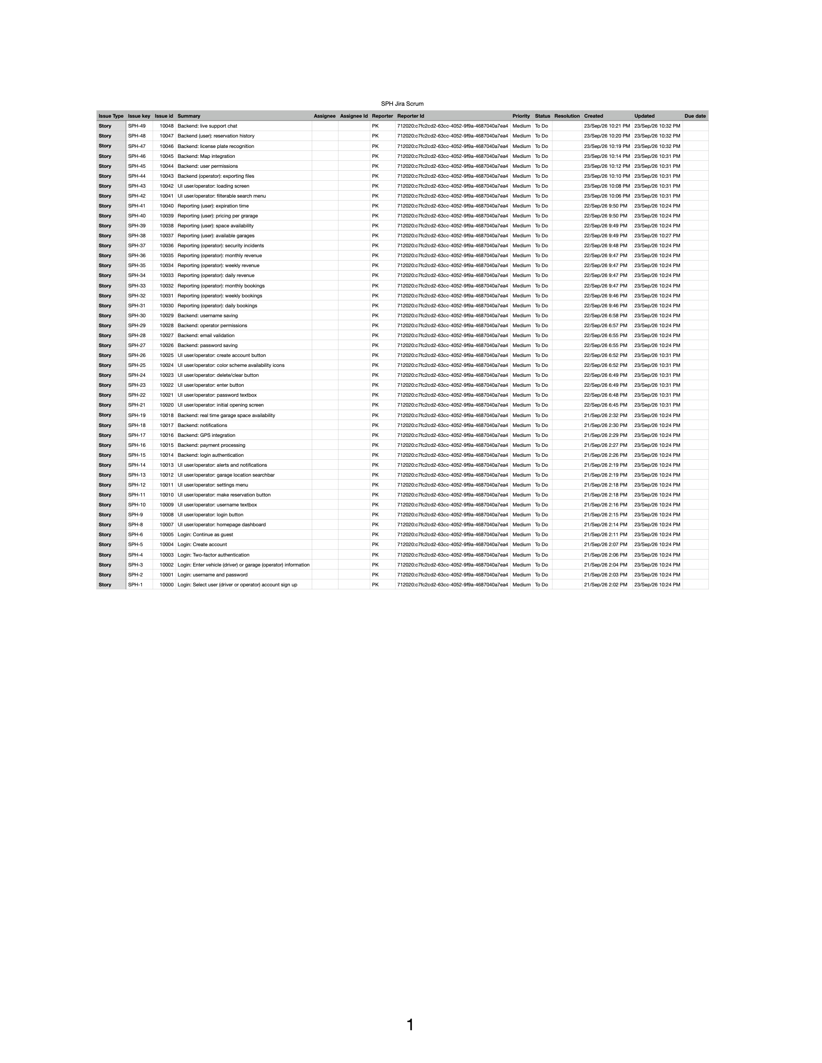
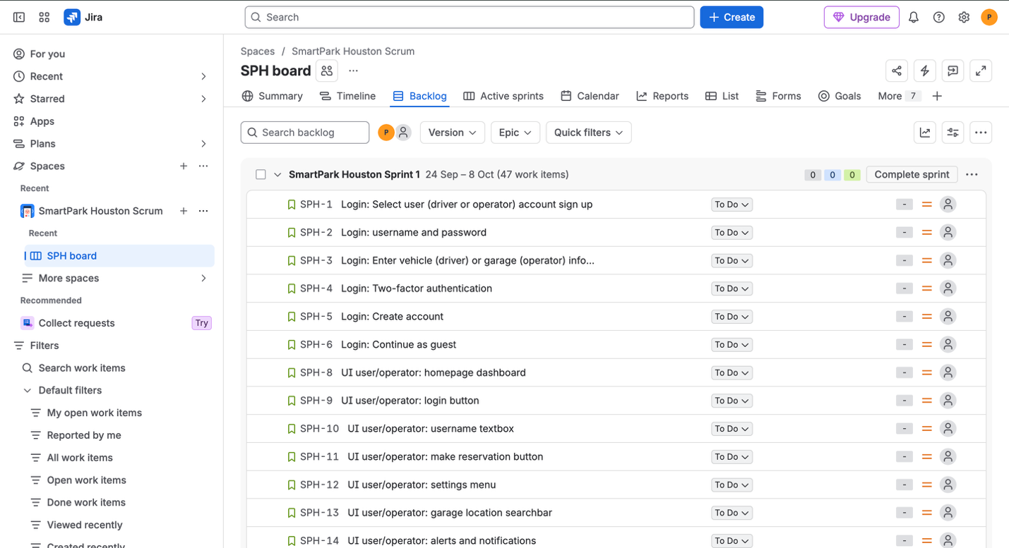

Risk Categories
Technical risks:
- App may not work without proper cellular connection
- Payment API failure
- License plate recognition technology not working
- Misrepresented spot availability due to malfunctioning sensors
- Code issues
- Licensing approval
- Housing infrastructure
Schedule risks:
- App launch delay
- Underestimated timeline
- City approval challenges or delays
- Third-party services approval delays
- Tasks not delivered on time
Financial risks:
- Scope creep
- Third-party service costs
- App temporarily stops working/outage
- Going over budget
People risks:
- Team member quitting
- Team member getting sick
- Team member fails to fulfill assigned task by deadline
- Team member incorrectly completes assigned task

Risk Register
Risk ID: TR01
Description: Payment API failure
Category: Technical risk
Probability: Medium
Impact: High
Owner: API developers
Response Strategy: Immediate action from API engineers to fix software
Status/Notes: Not started

Risk ID TR02
Description: License plate recognition technology not working
Probability: High
Category: Technical risk
Impact: High
Owner: Garage technician, software engineer
Response Strategy: Immediate action by on-location troubleshooting and/or fixing software. Mitigate risk by proper upkeep of hardware and regular software updates.
Status/Notes: Not started

Risk ID TR03
Description: App may not work without proper cellular connection
Probability: Medium
Category: Technical risk
Impact: High
Owner: App developers
Response Strategy: Immediate action, troubleshooting, and editing software. Mitigate risk by proper system testing and regular software updates.
Status/Notes: High priority

Risk ID TR04
Description: Misrepresented spot availability due to malfunctioning sensors
Probability: Medium
Category: Technical risk
Impact: Medium
Owner: Garage technician, software engineer
Response Strategy: Immediate action by on-location troubleshooting and/or fixing software. Mitigate risk by proper upkeep of hardware and regular software updates.
Status/Notes: Medium priority

Risk ID TR05
Description: Code issues
Probability: Medium
Category: Technical risk
Impact: High
Owner: App developers, software engineers
Response Strategy: Immediate action by updating software. Mitigate risk by assigning experienced individuals to the task and maintaining regular revisions of code.
Status/Notes: High priority

Risk ID TR06
Description: Licensing approval

Probability: Medium
Category: Technical risk
Impact: High
Owner: Project manager
Response Strategy: Accept delay, adjust project timeline. Communicate with licensing party and find alternatives.
Status/Notes: Medium priority

Risk ID TR07
Description: Housing infrastructure
Probability: Medium
Category: Technical risk
Impact: High
Owner: Project manager
Response Strategy: Adjust project timeline, reevaluate budget, find alternative infrastructure housing sites
Status/Notes: Medium priority

Risk ID SR01
Description: App launch delay
Probability: Medium
Category: Schedule risk
Impact: High
Owner: Project manager
Response Strategy: Adjust project timeline, accept delay.
Status/Notes: Medium priority

Risk ID SR02
Description: Underestimated timeline
Probability: High
Category: Schedule risk
Impact: High
Owner: Project manager
Response Strategy: Reevaluate goals and deliverables; make timeline adjustments. Mitigate by allowing flexibility in time estimates.
Status/Notes: High priority

Risk ID SR03
Description: City approval delays
Probability: Medium
Category: Schedule risk
Impact: High
Owner: Project manager
Response Strategy: Accept delay, adjust project timeline
Status/Notes: High priority

Risk ID SR04
Description: Third-party services approval delays
Probability: Medium
Category: Schedule risk
Impact: High
Owner: Project manager
Response Strategy: Accept delay, adjust project timeline
Status/Notes: Medium priority

Risk ID SR05
Description: Tasks not delivered on time
Probability: High
Category: Schedule risk
Impact: Medium
Owner: Project manager
Response Strategy: Accept delay, adjust project timeline. Mitigate – evaluate skills and capabilities of team members. Reassign tasks.
Status/Notes: High priority
Risk ID FR01
Description: Scope creep
Probability: High
Category: Financial risk
Impact: High
Owner: Project manager
Response Strategy: Mitigate by having an established timeline and strict list of deliverables; do not accept new requests. Make a plan for budget flexibility.
Status/Notes: High priority

Risk ID FR02
Description: Third-party service costs
Probability: Medium
Category: Financial risk
Impact: Medium
Owner: Project manager
Response Strategy: Make plan for budget flexibility. Find third-party provider alternatives
Status/Notes: Medium priority

Risk ID FR03
Description: App temporarily stops working/outage
Probability: Medium
Category: Financial risk
Impact: High
Owner: App developers
Response Strategy: Immediate action from software team. Mitigate risk by running regular tests and updates (during low traffic times)
Status/Notes: High priority
Risk ID FR04
Description: Going over budget
Probability: High
Category: Financial risk
Impact: Medium
Owner: Project manager
Response Strategy: Make plan for budget flexibility. Mitigate by avoiding additional, sudden requests (scope creep)
Status/Notes: Medium priority, not started (due to undisclosed budget limit)

Risk ID PR01
Description: Team member quitting
Probability: Medium
Category: People risk
Impact: Medium
Owner: Project manager
Response Strategy: Accept delay. Mitigate – evaluate skills and capabilities of team members. Reassign tasks.
Status/Notes: Not started

Risk ID PR02
Description: Team member getting sick
Probability: Medium
Category: People risk
Impact: Low
Owner: Team manager
Response Strategy: Transfer task to another developer
Status/Notes: Low priority

Risk ID PR03
Description: Team member fails to fulfill assigned task by deadline
Probability: Medium
Category: People risk
Impact: Medium
Owner: Software developer
Response Strategy: Mitigate – evaluate skills and capabilities of team members. Reassign tasks.
Status/Notes: Not started

Risk ID PR04
Description: Team member incorrectly completes assigned task
Probability: Medium
Category: People risk
Impact: High
Owner: Software developer
Response Strategy: Transfer task to another developer. Mitigate – evaluate skills and capabilities of team members. Reassign tasks.
Status/Notes: Not started

Communication Plan
Meeting cadence per team:
- Daily: 10-15 min., virtual. Team members of 2-4 people meet to discuss immediate progress, challenges, and completion of their group’s shared tasks
    - Individual development teams
      - Organized by team member as needed
  - Reporting methods: daily standups – 3 questions

- Weekly: 20-30 min, virtual or in-person. Project team of ~10-16 people with manager meet to discuss each department team’s progress over weeks, resolving interdepartmental challenges
    - All development teams and management
      - Organized by middle managers
  - Reporting methods: project management tools for visualization of progress (scrum board, gantt chart), technical details/reports

- Monthly: 30-45 min., virtual or in-person.
    - Upper management and stakeholders
      - Organized by executives
  - Reporting methods: metrics analysis, overview summary with focus on main accomplishments or setbacks

Role | Name | Team | Skill Level  Assumption | FTE % | Estimated Hours | Hourly Rate | Cost
Project Manager | Polina | Interdepartmental | High | 0.20 | 128 | $40 | $ 5120
Developer 1 | Carla | Mobile & Web Application | High | 0.70 | 448 | $70 | $ 31360
Developer 2 | Greg | Mobile & Web Application | Intermediate | 0.40 | 256 | $50 | $ 12800
Developer 3 | June | Backend/API | High | 0.60 | 384 | $60 | $ 23040
Developer 4 | Matt | Payment Integration | High | 0.60 | 384 | $70 | $ 26880
Developer 5 | Peter | Mapping and Location Services | High | 0.50 | 320 | $60 | $ 19200
QA/Tester | Sam | QA/Testing | High | 0.30 | 192 | $50 | $ 9600
QA/Tester | Paul | QA/Testing | Intermediate | 0.25 | 160 | $30 | $ 4800
UX | Paige | Mobile Application (all aspects) | High | 0.40 | 256 | $40 | $ 10240
UX | Javi | Web Application (all aspects) | High | 0.50 | 320 | $40 | $ 12800
DevOps | Brett | Backend/API | High | 0.60 | 384 | $70 | $ 26880
DevOps | Bella | Mobile & Web Application | High | 0.50 | 320 | $70 | $ 22400
BA | Fred | Interdepartmental | Intermediate | 0.30 | 192 | $50 | $ 9600
Subject Matter Expert | Tom | Interdepartmental | High | 0.10 | 64 | $65 | $ 4160
Subject Matter Expert | Rick | Interdepartmental | High | 0.10 | 64 | $70 | $ 4480
Product Owner | Stacy | Interdepartmental | High | 0.10 | 64 | $70 | $ 4480
Total |  |  |  |  | 3776 |  | $ 223,040

Roles and Resources Plan

Bottom-Up Cost Plan
16 week/4 month project, ~16 people
Team assumptions (taken from resource plan above):
-PM: $ 5120
-Developer 1: $ 31360
-Developer 2: $ 12800
-Developer 3: $ 23040
-Developer 4: $ 26880
-Developer 5: $ 19200
-QA/Tester: $ 9600
-QA/Tester: $ 4800
-UX: $ 10240
-UX: $ 12800
-DevOps: $26880
-DevOps: $ 22400
-BA: $ 9600
-SME: $4160
-SME: $ 4480
-PO: $ 4480
Labor subtotal: $ 223,040
Infrastructure & other costs:
-Licenses: $15,000
-APIs: $15,000
-Security: $20,000
-Hardware: $30,000
-Training: $15,000
-Cloud hosting: $3,000/month*4
Subtotal: $107,000
Overhead/Benefits (25% of labor): 0.25* $223,040= $55,760
Total before contingency: $223,040+$107,000+$55,760=$385,800
Contingency; (15%) = 0.15*$385,800=$57,870

Grand total: $443,670 (~$445,000)

Cashflow
Month | Labor | Infra | Licenses | Benefits (25%) | Contingency (15%) | Total
Month 1 | 52,620 | 23,000 | 3,000 | 13,155 | 13,767 | 105,542
Month 2 | 60,600 | 35,000 | 5,000 | 15,150 | 17364 | 133,114
Month 3 | 60,620 | 19,000 | 4,000 | 15,155 | 14,817 | 113,592
Month 4 | 49,200 | 14,000 | 2,000 | 12,300 | 11,625 | 89,125
Total | 223,040 | 92,000 | 15,000 | 55,760 | 57,870 | ~$445,000

RACI Matrix
R = Responsible
A = Accountable
C = Consulted
I = Informed
Task/Role | PM | Developer | QA/Tester | UX | DevOps | BA | SME | PO
Requirements | A | C | I | C | C | I | C | A
Design | A | R | I | R | C | I | C | A
Implementation | C | R | C | R | R | I | C | C
System Testing | I | C | R | C | C | C | C | C
Release | C | I | C | I | A | C | I | I

Power-Interest Grid
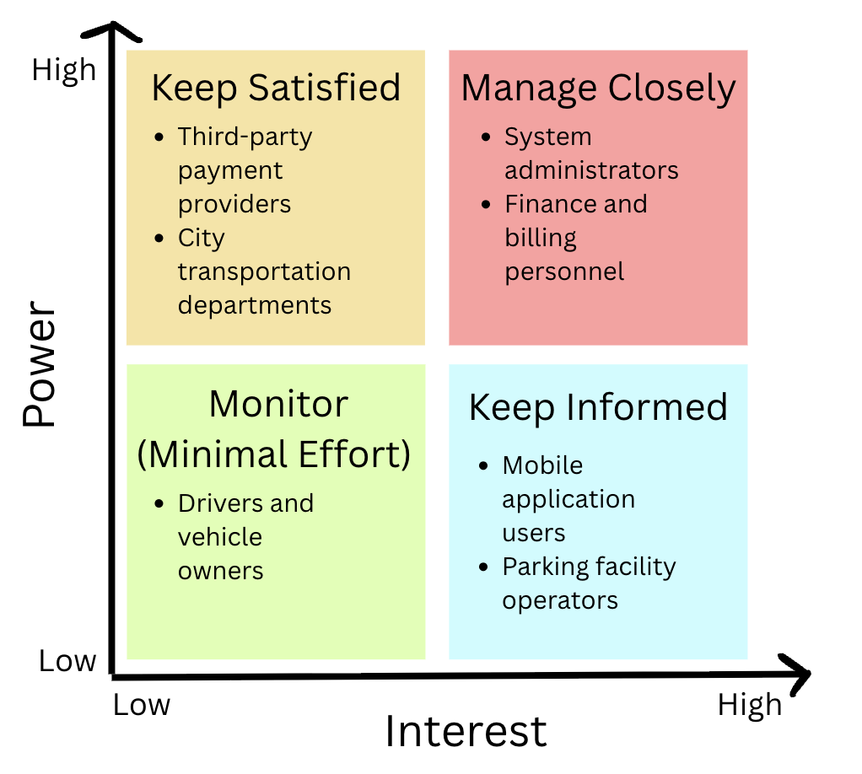

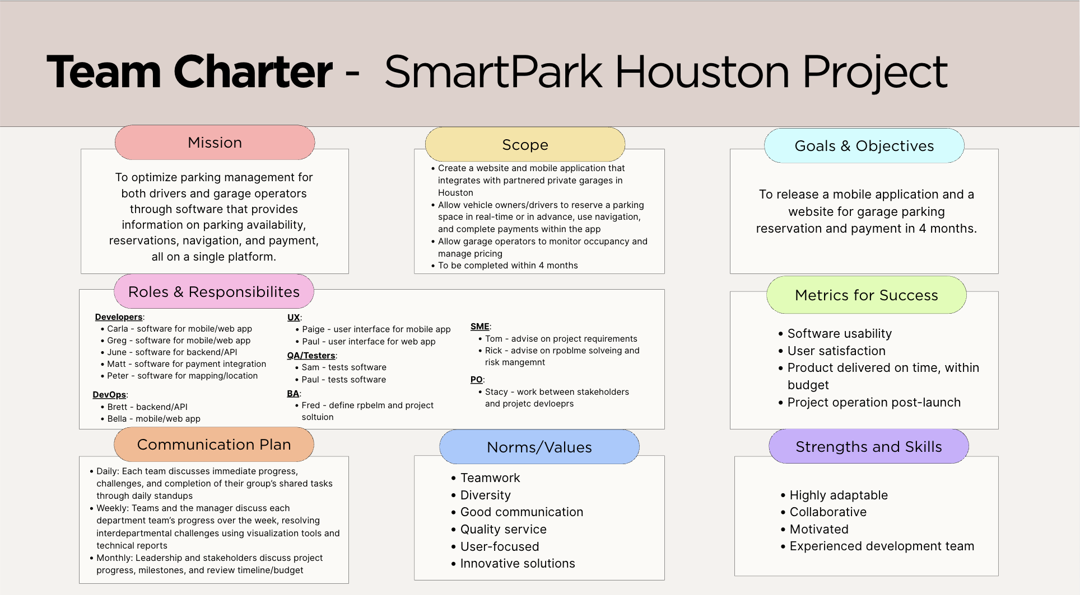
Team Charter

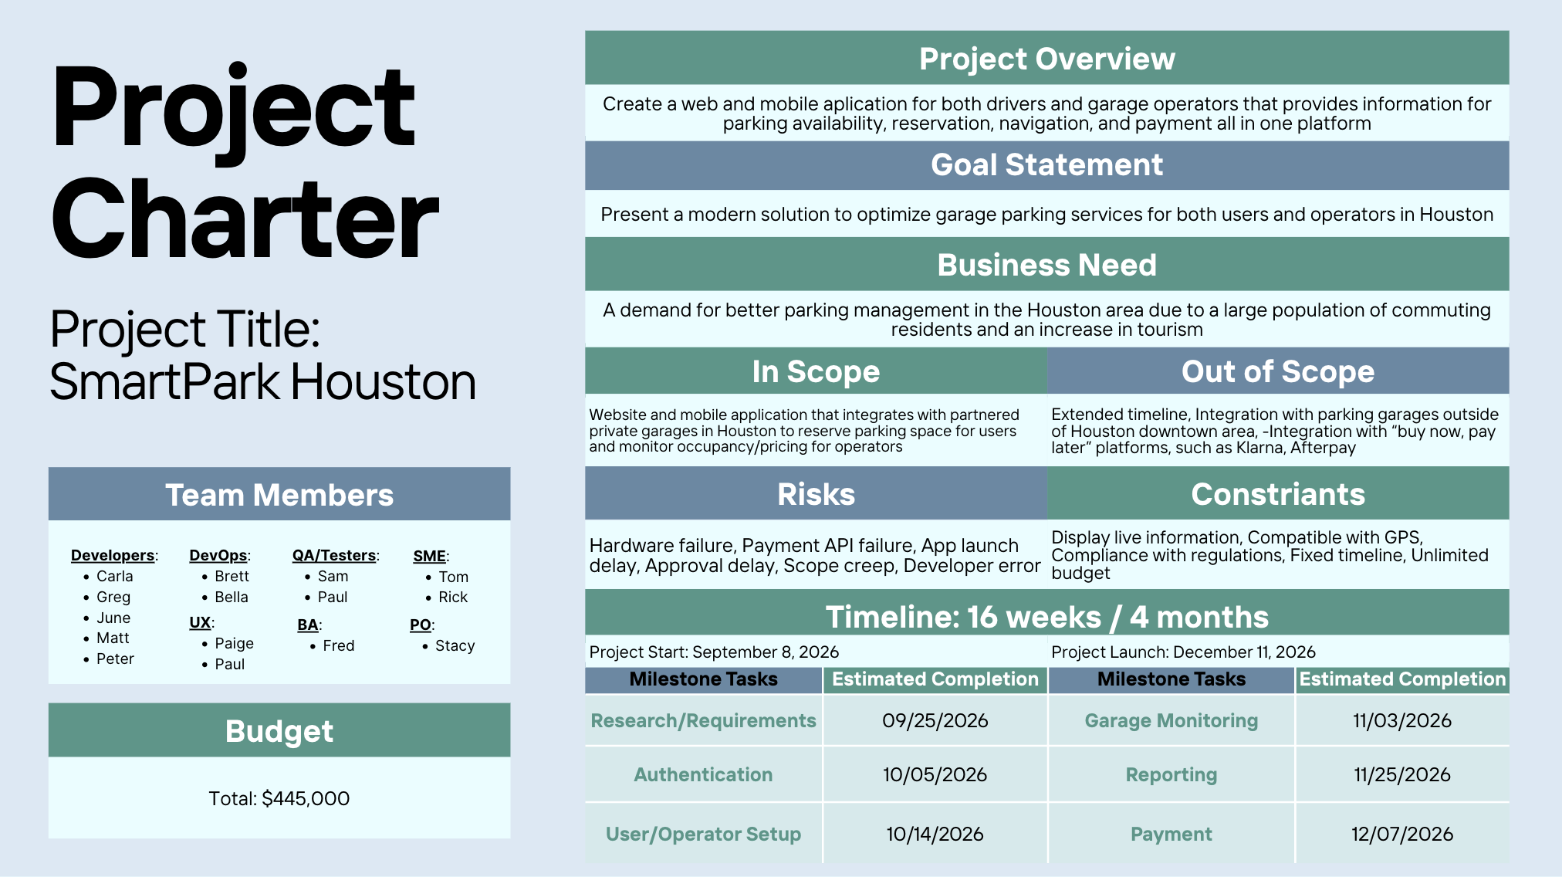
Project Charter

